**Ron Steinberg 2 Year Memorial**

**Car Get Together**

**Monday, July 17, 2023 from 6:30 pm to 8:30 pm**

**Super Duper Burger**

**5399 Prospect Rd (at Lawrence Expy) in San Jose**

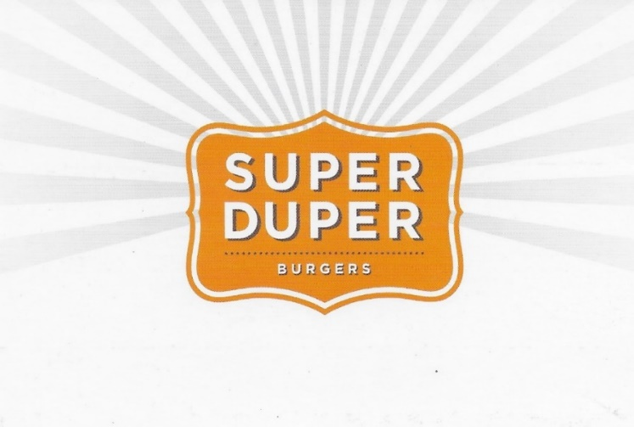**Bring your classic car**

